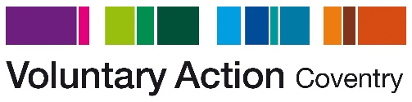
Background
Improving Lives is for anyone aged 18 years and over who wants to know more about volunteering opportunities in Coventry and have a go at some volunteering activities to increase their confidence and well-being.
The Improving Lives course consists of 12 structured sessions of engaging activities, discussions, visits and support that take place over two-sessions per week. Additionally, participants can access to one-to-one support and guidance to help them with volunteering or employment barriers.
The course aim is to support participants to focus on their futures and realise their potential, improving confidence in their own skills and abilities and what they have to offer, and to learn about and practice elements necessary for finding, applying for and securing volunteer or work roles.

