Job Title: Children and Young Person’s Support Worker
Hourly Rate: £12
Employment Status: Permanent
Responsible To: CYP Coordinator

Location: Opportunities in Coventry.
Opportunities in Warwickshire.
 | CRITERIA | EVIDENCE
Experience | Desirable  - Previous experience of working with children and young people with complex needs and disabilities | Application Form and Interview.
Skills & Ability | Essential  - Ability to use person centred approaches to plan & deliver social, leisure and recreational opportunities for children and young people with learning disabilities and complex needs  - Ability to communicate effectively with colleagues, parents, carers, children & young people  - Good written and verbal communication skills  - Practical arts, crafts, music, drama, sports or games skills  - Have held a position of responsibility  - To work as part of a team  - Demonstrate an ability to motivate and encourage children and young people with complex needs to participate in activities  - Show an understanding of alternative methods of communication that could be used with non-verbal children and young people  - To plan and deliver creative programmes to meet individual levels of ability and need  - Willing to undertake further training  - Be able to participate in sports and other physicals activities  - Demonstrate an ability to work on own initiative | Application Form and Interview.
Training & Qualifications | Desirable  - Children and Young People Workforce Development qualification Level 2 relating to children and young people or a willingness to undergo training. | Interview and Application Form

Who We Look For
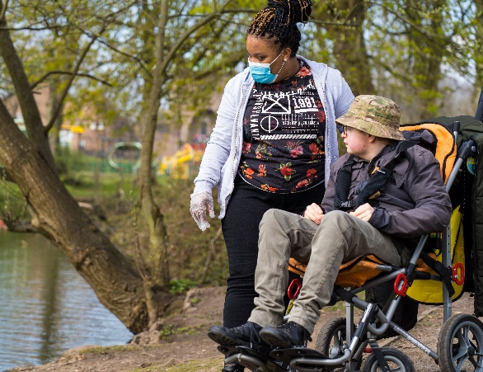
Are you a warm, personable, and caring individual who can empower, support and care for children and young people with a learning disability?
Do you have passion for what you do, are a good communicator and have good problem-solving skills?
Midland Mencap is looking to recruit support workers to provide social and recreational activities across Coventry for children and young people with complex needs.
We place a high value upon integrity, ethical standards, and a commitment to excellence.
If you have experience working with children and young people with complex needs that’s a bonus. But don’t be put off if not. We value transferable skills from all backgrounds and provide comprehensive training to all our staff.
What Does A Support Worker Do?
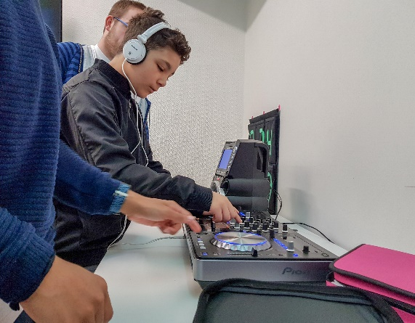
Support Workers are responsible for providing the appropriate support to children and young people either within their own home or within the local community.
The ideal candidate will be able to work in a caring and person-centred way, enabling children and young people to access social and recreational opportunities which are fun, safe and meaningful.
Duties and Responsibilities
- To provide a person-centred approach when providing activities and support for children and young people with complex needs.
- To take the lead for specific tasks as designated by the coordinator.
- To mentor and support new staff during their probationary period.
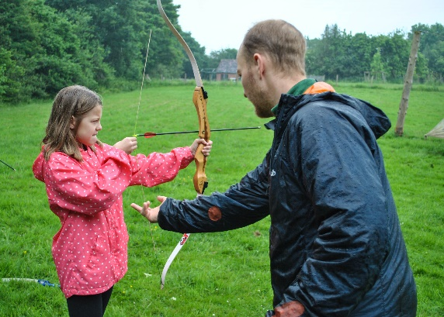
- To undertake training and take responsibility for children/young person who require tube feeding or emergency medication.
- Ensure that all information for a designated group of children is kept up to date including “All About Me’s” protocols and risk assessments
- Ensure the safety and wellbeing of children and young people by proactively managing safeguarding principles and practises.
- Maintain a safe, creative and stimulating environment for children and young people’s social, leisure and recreational activities
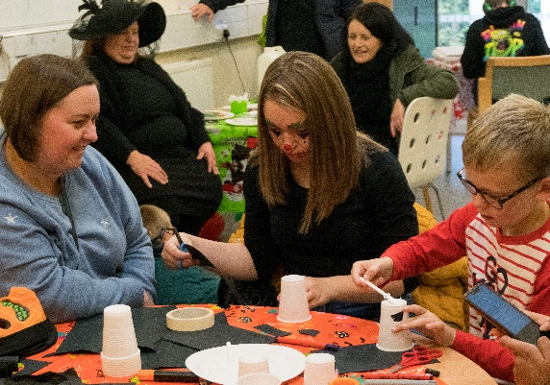
- Attend staff meetings before and after sessions on a planned basis to discuss and assess the progress of the service
- Attend training sessions
- Support children & young people to participate in arts and crafts, games, sports, drama, music, & outings
- Follow financial and administrative procedures as directed by the Children and Young Person’s Coordinator

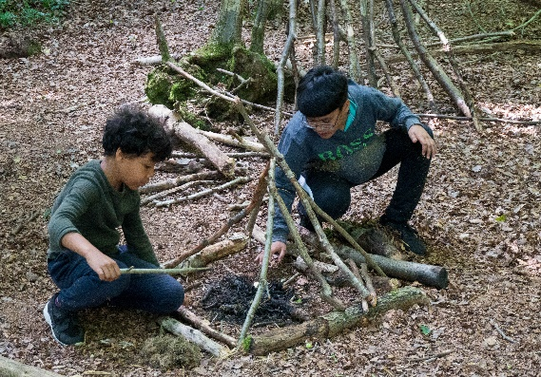
- Follow first aid procedures and keep records of all accidents, incidents and treatment given
- Provide personal care when needed respecting the dignity and privacy of the individual at all times.
- Monitor and evaluate children and young peoples’ progress through observation and record keeping.
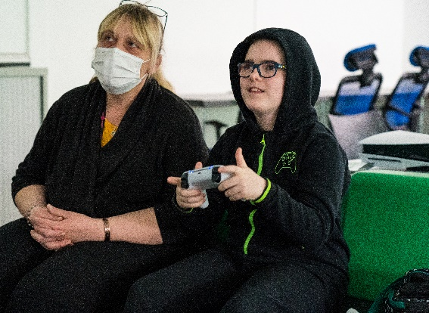
- Ensure that responsibilities are carried out in accordance with Health and Safety legislation, and Midland Mencap’s Equal Opportunities, Child Protection Policies and Ofsted regulations
- Ensure appropriate professional boundaries with children, young people, parents and carers, staff and volunteers are maintained across the service
- Be available to work flexible hours city-wide
- Participate in planned regular meetings with the Children and Young Person’s co-ordinator and other Midland Mencap colleagues

