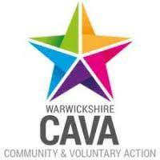







**Voluntary Action Coventry**

**VCSE Mental Health Alliance Partnership Officer**

This post is offered on a 12-month basis but may be extended subject to funding

**32 hours per week – salary £32,910 per annum pro rata per annum plus 7% pension**

VAC is seeking to appoint Partnership Officer to support the development of the VCSE (Voluntary, Community and Social Enterprise) Mental Health Alliance, championing the role the voluntary and community sector plays in supporting people with mental health issues in Coventry and Warwickshire and building effective relationships with other agencies to ensure the best outcome for service users.

For an application pack, please e-mail [info@vacoventry.org.uk](mailto:info@vacoventry.org.uk) or alternatively download an application from <https://www.vacoventry.org.uk/page/vacancies-0> **Please note this post is subject to a DBS clearance check and is fixed for 12 months.**

VAC application form only, no CVs accepted. Please do not attach a CV to your VAC application form.

**Closing date for applications: 10am, Monday 10 May 2021**

Interviews will be held on 17, 18 and 19 May 2021

*Registered Charity No: 514518*