Information about Healthwatch Coventry

What we do
Healthwatch is the independent local champion for Coventry people for health and social care services. People’s views come first – especially those who find it hardest to be heard. We champion what matters to local people and work with others to find solutions.

We are part of a Network of 151 local Healthwatch in England and are supported by Healthwatch England.

The Healthwatch network was set up through an Act of Parliament so we have functions written into legislation.

Our role is to:

- Ask people what they think about services to build a picture of where services are doing well and where they can be improved.

- Influence the planning and delivery of NHS and social care services based on what local people tell us.

- Provide an information service to the public about local health and social care services to help people find their way; make choices and understand their rights.

- Provide information to inform the work of Healthwatch England.

How we do this

These are some of our approaches:

- Visiting NHS and care services to see how they work

- Running public surveys

- Running focus and discussion groups

- Going out visiting places in the community and working with other organisations

- Running social media campaigns

How we are set up?
Healthwatch is funded through national money which is distributed through local councils. There is a duty on local council’s to commission a local Healthwatch so they do this every few years.

Here Coventry City Council has a new 3-year funding agreement with Voluntary Action Coventry for the running of Healthwatch Coventry between 1 August 2020 – July 2023. Voluntary Action Coventry is a local Charity.

Healthwatch Coventry has a Steering Group with a membership of individual local people and voluntary groups which has responsibility for the direction and oversight of Healthwatch work.

Volunteers play a key role in Healthwatch and carry out roles in most of what we do and therefore adding greatly to the capacity to do our work.

Find out more about what we do
Visit our website: www.healthwatchcoventry.co.uk

Read about what we did in 2019-20 in our Annual Report www.healthwatchcoventry.co.uk/sites/www.healthwatchcoventry.co.uk/files/Healthwatch_Coventry_Annual_Report2019-20FINAL.pdf

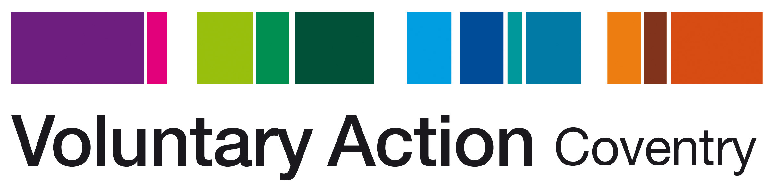

About Voluntary Action Coventry (VAC)
Our organisation (VAC) supports and enables voluntary activity in Coventry, working with both individuals and voluntary and community organisations to tackle inequalities and disadvantage in the city.

VAC works with people from all backgrounds including NEETS, long-term unemployed, those recovering from drug or alcohol misuse, those with mental health issues, people with learning difficulties, people with English as a second or other language, ex-offenders and individuals with low-level self-esteem and confidence.

We aim to increase and better support social action and community resilience in Coventry, strengthening communities and improving quality of life for all.

We have run an accredited Volunteer Centre for 19 years and continue to provide a service that links people who want to share their time and skills with organisations that involve volunteers.

We also hold a huge range of information about voluntary, community and social enterprises (VCSE) in Coventry through our work supporting the VCSE Alliance, which we can draw on to source opportunities for clients.

