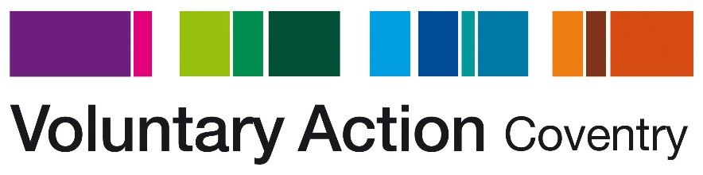

PR and Communication Officer

Background information

About Voluntary Action Coventry (VAC)
Our organisation (VAC) supports and enables voluntary activity in Coventry, working with both individuals and voluntary and community organisations to tackle inequalities and disadvantage in the city. VAC works with people from all backgrounds including NEETS, long-term unemployed, those recovering from drug or alcohol misuse, those with mental health issues, people with learning difficulties, people with English as a second or other language, ex-offenders and individuals with low-level self-esteem and confidence. We aim to increase and better support social action and community resilience in Coventry, strengthening communities and improving quality of life for all.

We have run an accredited Volunteer Centre for 20 years and continue to provide a service that links people who want to share their time and skills with organisations that involve volunteers. We also hold a huge range of information about voluntary, community and social enterprises (VCSE) in Coventry through our work supporting the VCSE Alliance, which we can draw on to source opportunities for clients.

We run several projects that are focused on supporting people to overcome barriers and move towards volunteering or employment or to take steps to overcome loneliness and isolation. Please visit out website www.vacoventry.org.uk for more information about our projects.

We previously fulfilled a role in the City where we supported voluntary and community groups to set up, provided advice and information on policies and charity registration, constitutions and funding. We have moved away from this type of work and are keen to reposition ourselves and ensure our stakeholders fully understand what we currently offer and the role we play supporting citizens to play an active part in their community.

