Background information

This is an opportunity to be part of a brave and bold transformation of community mental health – providing easy access to support for people with severe and continuing mental illness.

Coventry and Warwickshire Health and Care Partnership has secured funding of £11.9 million over three years from NHS England / NHS Improvement. The Health and Care Partnership is the Coventry & Warwickshire Integrated Care System: sharing knowledge and pooling resources, working to help everyone lead healthier and happier lives, be part of a strong community and benefit from effective and sustainable health and care services where and when they need them most.

This is a once in a generation opportunity to boldly transform our community mental health services. The commitment is to provide an enhanced service which is easily accessible, providing integrated and seamless care and support for people experiencing mental distress.

The principles and detail of the transformed service have been co-designed by a multi-sector alliance of partners including health, Local Authorities, voluntary and community sector organisations (VCSE) and people with lived experience of mental health challenges.

The new transformed service will provide people with severe and continuing mental illness with easier and faster access to services delivered at neighbourhood level by a range of partners across health, social care and VCSE - equal partners working to shared principles, to best meet our local population’s needs. The service will be trauma informed throughout, shifting the focus from ‘what’s wrong with me’ towards ‘what’s happened to me’.

Together a new community-based service will be established that will include access to talking therapies, improved physical health care, employment support, personalised care tackling the root cause of the problem, medicines management and support for self-harm and co-existing substance use.

The areas of work specifically highlighted are to support services for adults with severe and continuing mental illness (SMI) including:
- Personality and complex trauma
- Eating Disorders
- Community Rehabilitation

A focus on health inequalities is a key piece of this work. People with SMI experience health inequalities with poorer physical health and lower life expectancy, lower employment rates, financial security, social isolation and housing support needs.

Dr Richard Onyon, Consultant Psychiatrist and Associate Medical Director at Coventry and Warwickshire Partnership NHS Trust, said: “Over the next three years, we aim to develop a sustainable community mental health care system that will provide individuals with seamless care across physical and mental health services.

Our plans for this new system-wide provision of support for people’s mental health is an ambitious but exciting one. The work will include the establishment of invaluable, new roles including people who have lived experience of mental health difficulties. We have already begun to establish stronger links with GPs, with new Mental Health Workers starting to be based in surgeries. Our aim is to better use all health, social care and community resources available and to reduce health inequalities which exist in some areas and for some more vulnerable groups.”

Transformation funding includes an Innovation Fund designated for the VCSE, to enable organisations to deliver support which adds value to existing statutory services.

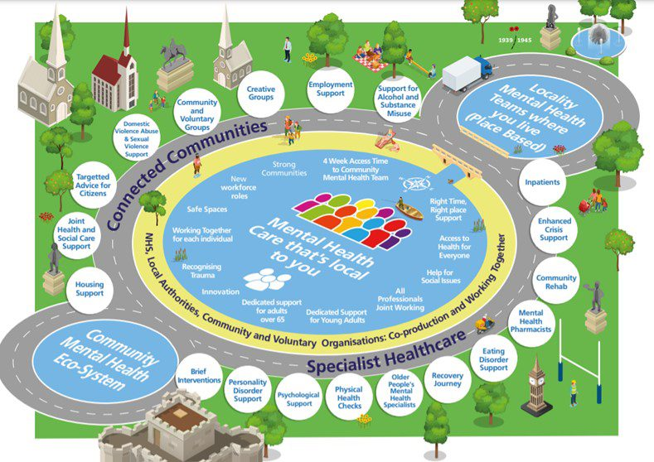

Existing structures and mechanisms:

CWPT
Coventry and Warwickshire Partnership Trust provides a full range of expanding physical, mental health and learning disability services to children, young adults, adults and older adults over many sites across Coventry, Warwickshire and Solihull.

Community Mental Health Transformation Board
This group meets monthly and oversees the delivery of the transformation programme, it includes representation from VCSE organisations: WCAVA, VAC and Rethink.

Co-Production
Rethink and Coventry & Warwickshire Grapevine are leading on the co-production work within the programme.

Dedicated Focus/Theme groups
These structures are within the Community Mental Health Transformation programme:
- Personality and complex trauma
- Eating Disorders
- Community Rehabilitation

Working Together
An alliance of providers across Coventry and Warwickshire ranging from small community- based organisations to larger community, faith and user-led organisations, locally active in the provision of locally tailored support to people ranging from mild-severe mental health problems.

Coventry and Warwickshire VCSE Mental Health Alliance
A newly forming entity that is focused on championing the role of the VCSE in supporting people with mental illness. Their focus is on ensuring the voices of VCSE organisations and their clients/service users are listened to and considered within decision making structures.

New structure
The VCSE Community Mental Health Team
Based within the infrastructure organisations of WCAVA (Warwickshire Community & Voluntary Action) and VAC (Voluntary Action Coventry) the newly formed VCSE Community Mental Health Team will endeavour to ensure that the voluntary and community sector is effectively engaged in shaping the transformation – drawing on their experience of supporting individuals and communities less well served by current provision.

There are four posts that comprise the VCSE Community Mental Health (CMHT) Team:

Programme lead:
- To contribute to the vision of the Coventry and Warwickshire Health and Care Partnership to boldly transform community mental health services.
- To provide an overarching role linking VCSE and statutory agencies to improve access to mental health services for people in Coventry and Warwickshire, working with the Community Mental Health Transformation Teams, Working Together group, and the VCSE MH Alliance.
- To develop and maintain routes of influence between sectors.

Liaison Officer/s Coventry & Liaison Officer Warwickshire
- Build relationships with VCSE organisations in Coventry and Warwickshire contributing to the CMHT key areas of supporting people with severe and enduring mental health conditions, in particular: personality and complex trauma, eating disorders or community rehabilitation.
- Support the understanding of the system as to the role and value of the VCSE sector.
- To work towards equal access to services for underrepresented groups

VCSE Mental Health Administrator
- To promote the Innovation fund
- To support the creation of application procedures around the Innovation Fund
- To administer the dissemination of Innovation funding to VCSE groups aligned to community transformation priorities, including follow up monitoring and impact reporting
- To support the joint work between the VCSE and other partners through ‘Working Together’
The Innovation fund will have a specific focus on the health and life inequalities of people with SMI, Including BAME and LGBTQIA+ communities.

Whilst the posts are employed by WCAVA and VAC we endeavour to create a ‘team’ approach where collaboration and joint working is the norm.

