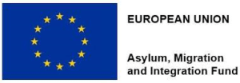
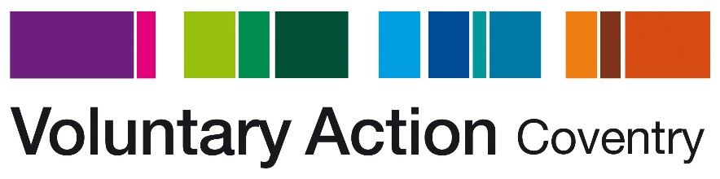

Re: Post of Volunteering Support Assistant

Background

About Voluntary Action Coventry (VAC)
Voluntary Action Coventry established in 1957 is a registered charity and company limited by guarantee. We are passionate about promoting and enabling voluntary activity in Coventry, working with both individuals and voluntary and community organisations to tackle inequalities and disadvantage in the city. We aim to increase and better support social action and community resilience in Coventry, strengthening communities and improving quality of life.
Since 1999 we have run a Volunteer Centre in Coventry, providing information to individuals on volunteering opportunities that they can undertake and helping voluntary and community organisations to recruit volunteers. We work with beneficiaries aged from 15+ from all backgrounds including NEETS, long term unemployed, those at risk of redundancy, those with mental health issues, people with learning difficulties, lone parents, carers, people with English as a second or other language, ex-offenders and individuals with low level self esteem and confidence.

VAC have many years’ experience of engaging with marginalised and excluded people, and we endeavour to ensure that no one is excluded from our support. All are welcomed regardless of ability, gender, race, religion, status, socioeconomics, or sexuality.
We use our connections with voluntary and community organisations to promote the inclusion of refugees and to help illustrate the role they can play as volunteers with a wealth of skills and experience that can enhance the voluntary and community sector in the city.

Integrate Coventry

The project aims to help Third Country Nationals to rebuild their lives in safety, become fully self-sufficient and establish themselves within the wider community in Coventry.

In partnership with Coventry Refugee & Migrant Centre, Foleshill Women’s Training, Belgrade Theatre and Coventry City of Culture 2021 we aim to aid integration through a range of innovative interventions and support.

Within this project VAC will work with clients referred as ‘integration ready’ by CRMC and FWT. VAC will begin their work with clients by providing enrichment workshop sessions that help clients increase their confidence, communication skills and awareness of Coventry. The sessions will help individuals examine their strengths and weaknesses and how they function in a team environment. Following these workshops clients will progress to workshops and 1:2:1 support around volunteering, once clients are ‘volunteer ready’ VAC will help them to identify suitable placements taking into account their interests, aspirations, access needs and any other barriers in order to find the right placement for each person. VAC will monitor clients in their volunteering placements providing advice and support as necessary.

This project has been part funded by the European Union Asylum, Migration and Integration Fund. Making management of migration flows more efficient across the European Union.

