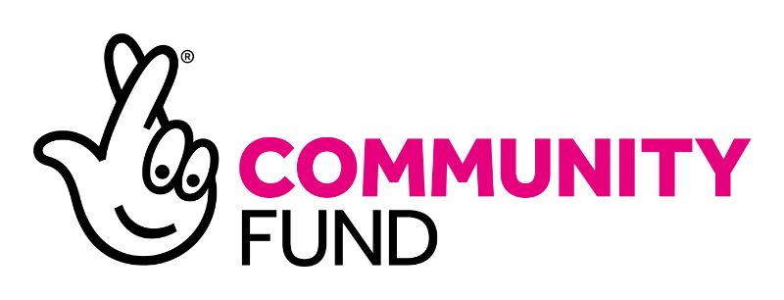

Re: Post of Chat Central Engagement Officer

Background information
We have secured further funding through the National Lottery Community Fund to deliver a three-year project aimed at helping people in Coventry to overcome loneliness and isolation.

About Voluntary Action Coventry (VAC)
Our organisation (VAC) supports and enables voluntary activity in Coventry, working with both individuals and voluntary and community organisations to tackle inequalities and disadvantage in the city. VAC works with people from all backgrounds including NEETS, long-term unemployed, those recovering from drug or alcohol misuse, those with mental health issues, people with learning difficulties, people with English as a second or other language, ex-offenders and individuals with low-level self-esteem and confidence. We aim to increase and better support social action and community resilience in Coventry, strengthening communities and improving quality of life for all.

We have run an accredited Volunteer Centre for 21 years and continue to provide a service that links people who want to share their time and skills with organisations that involve volunteers. We also hold a huge range of information about voluntary, community and social enterprises (VCSE) in Coventry through our work supporting the VCSE Alliance, which we can draw on to source opportunities for clients.

Our Chat Central project
We want to support people experiencing isolation to access volunteering opportunities and community activity that could help them to feel positive about themselves and give them the confidence to form new social connections and relationships. We receive a large number of referrals from health professionals that have advised their clients to volunteer, such as social workers, mental health support staff, nurses and therapists as they recognise volunteering is a route to increased social connection and engagement with others, which is essential for healthy mental wellbeing.
Our Engagement Officer and Support Officer will work with individuals to identify what support they need, whether it is a soft introduction to volunteering by an accompanied visit to see what volunteers do at different organisations or to explore what would help them experience connection and engagement with others perhaps by joining a group or class or linking via social media with others. The staff will bring participants together in pairs or small groups where they have similar interests to meet informally for coffee and a chat with a view that they could progress to going to activities together to ‘give it a go’.
The Chat Central project will build on the initial 2 years of activity engaging people from all areas of Coventry, whether young or old, new to the city or an established resident. Our programme of activity will support anyone aged 18-plus experiencing loneliness, social withdrawal, low self-esteem and low self-confidence.

To increase the capacity of the project to support more people we will recruit a team of Chat Central volunteers who will help run the drop-in sessions spending time chatting with clients, visiting existing groups to talk about the project and undertaking promotion in communities.

