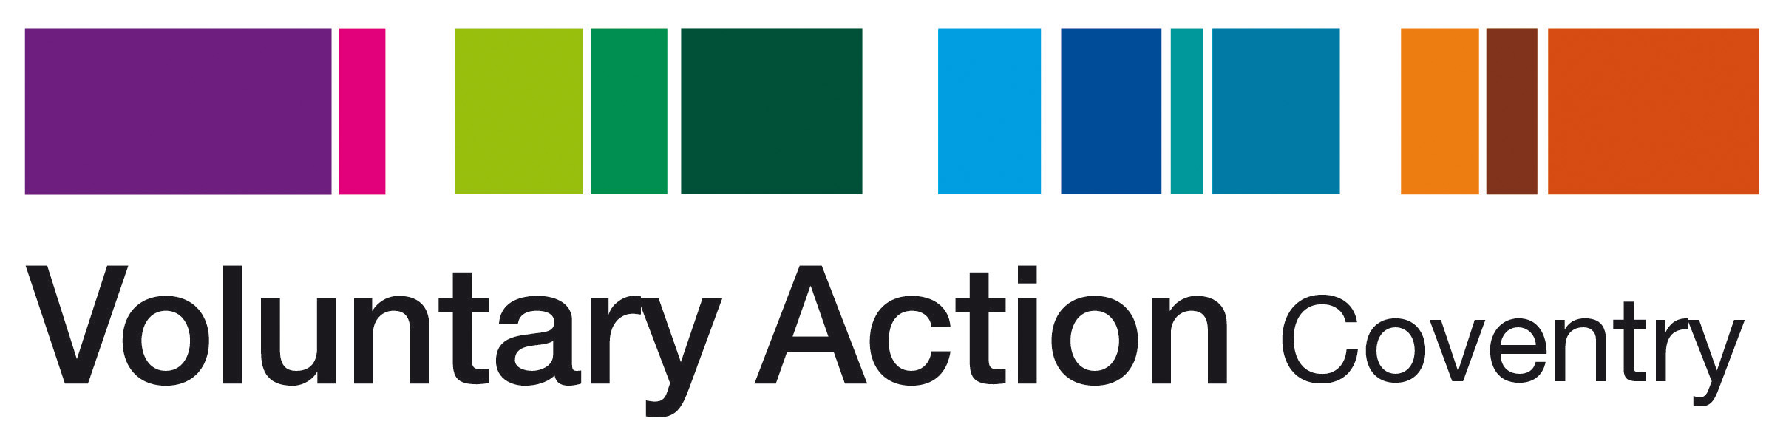

Coventry 4 Good Action Team Leader

Background Information
Voluntary Action Coventry established in 1957 is a registered charity and company limited by guarantee. We’re passionate about promoting and enabling voluntary activity in Coventry, working with both individuals and voluntary and community organisations to tackle inequalities and disadvantage in the city. We aim to increase and better support social action and community resilience in Coventry; strengthening communities and improving quality of life.

Since 1999 we have run a Volunteer Centre in Coventry, providing information to individuals on volunteering opportunities that they can undertake and helping voluntary and community organisations to recruit volunteers. We have also delivered national programmes around youth volunteering such as Millennium Volunteers and Vinvolved. We work with beneficiaries aged from 15+ from all backgrounds including NEETS, long term unemployed, those at risk of redundancy, those with mental health issues, people with learning difficulties, lone parents, carers and individuals with low level self esteem and confidence.

Coventry 4 Good is an initiative from Voluntary Action Coventry. It strengthens voluntary and community groups by making it easier to help local good causes through the giving of time and skills, money and resources. It is about everybody helping to make Coventry a great place to live and work by supporting local good causes.

It is about community groups, charities, social enterprises, businesses and individuals working in harmony to form partnerships that are, ultimately, less dependent on statutory and grant funding.

All donations received by Coventry 4 Good are distributed to local good causes.

Coventry 4 Good Action Team
Voluntary Action Coventry have secured funding through the Armed Forces Covenant Fund to develop a project aimed at helping ex-service personnel and their families to integrate with civilian communities through the sharing of time, skills and resources.

The project will help integrate Armed Forces and civilian communities by creating strong sustainable links between the Armed Forces community and civilian communities in Coventry. Through Coventry 4 Good we can demonstrate that by working together there is a shared benefit that impacts positively on both the civilian and Armed Forces communities.

The project will bring people together to tackle local issues or to participate in joint activity where the skills and time volunteered by everyone involved are recognised and valued. Collaborating in this way will help overcome barriers that prevent integration of Armed Forces personnel, by increasing the social integration, emotional wellbeing and health of Armed Forces personnel and their families.

Participants will mix with other ex-service personnel and their families, sharing experiences and building a supportive group ready to build links with local community organisations through one-off projects that may lead to on-going relationships and regular volunteering placements.

Participants will have an opportunity to tackle social isolation, issues with low level self esteem and barriers to integration through applying their skills and knowledge in a civilian setting that could help shape their employment choices and skills development progression.

The Action Team Leader will build links with local barracks and TA centres – in particular to help identify early service leavers, they will strengthen links with local agencies such as Coventry & Warwickshire Partnership Trust Mental Health Teams and the Veterans Project, IAPT, Here to Help-Alcohol Liaison Service as well as voluntary sector organisations such as Coventry & Warwickshire SSAFA, Coventry & Warwickshire Mind, Cyrenians, AIMHs, Compass etc. who may be working with ex-service personnel and their families that would benefit from the project.

The Action Team Leader will be responsible for recruiting participants onto the project and for liaising with voluntary and community groups to identify suitable activities. Voluntary and Community organisations often have a need for volunteers on an ad hoc basis to undertake specific activity alongside their regular volunteering roles.

